Compute as a Service
Servers
The first building block that you need to host an application is a server.
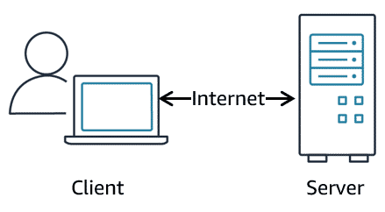
Compute services
- AWS App Runner
- Batch
- EC2
- EC2 Image Builder
- Elastic Beanstalk
- Lambda
- Lightsail
- AWS OutPosts
- Serverless Application Repository
- AWS SimSpace Weaver
Three types of compute options are available:
- Virtual machines (VMs)
- Container services
- Serverless.
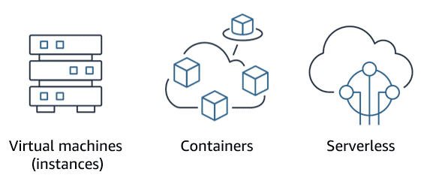
Choosing Right Compute Option
Prior infrastructure knowledge- VM
To run virtual machines, you install a hypervisor on a host machine. a hypervisor is software or firmware that makes it possible to share physical hardware resources across one or more virtual machines. The hypervisor provisions the resources to create and run your VMs.
Resources
For more information, see the following resources:
- AWS whitepaper: Compute Services(opens in a new tab)
- AWS website: Compute for Any Workload

